Atomic Project

**Book Title**

**Book Title**

**Step-1: User Story**

* As a user I want to add book names so that this will show on the list. (C)
* As a user I want to add author names so that this will show beside book names on the list. (C)
* As a user I want to edit any book entry so that I can correct any mistakes. (U)
* As a user I want to view the book names individually. (RS)
* As a user I want to view the list of most seller books so that I know what people like. (RM)
* As a user I want to soft-delete my book names from the list so that I can recover it.
* As a user I want to recover my soft-deleted book names from trash list.
* As a user I want to delete any book name from the list. (D)

**Step2: Use Case**

**Add book name& author name:**

|  |  |  |
| --- | --- | --- |
| **Requirements** | **Key Features** | **Acceptance Criteria** |
| As a user I want to add book names so that this will show on the list. | To make a user friendly, Data should be saved without refreshing page. (Ajax) | 1.    Anyone can add book name without any problem.(Core features)  2.    User should see the success/failure message. (Message)  3.    User can enter only letter, number and -,_. (Format Validation)  4.    No empty value is accepted.(Empty Validation)  5.    No book name can be entered repeatedly.( Unique validation)  6.    Input should be Sanitized to secure the application  (Sanitization)  7.   In case of invalid input JavaScript message should be displayed. (Usability/User Friendly Interface)  8. Use relevant picture to use as a submit button.(Look)  9. I want to reset form content anytime. |

**Edit book name:**

|  |  |  |
| --- | --- | --- |
| **Requirements** | **Key Features** | **Acceptance Criteria** |
| As a user I want to edit any book entry so that I can correct any mistakes. | To make a user friendly, Data should be saved without refreshing page. (Ajax) | 1.     Anyone can edit the book name & author name without any problem.(Core features)  2.     User should see the success/failure message. (Message)  3.     User can enter only letter, number and -, _. (Format Validation)  4.     No empty value is accepted.(Empty Validation)  5.     No book name can be entered repeatedly.( Unique validation)  6.     Input should be Sanitized to secure the application  (Sanitization)  7.     In case of invalid input JavaScript message should be displayed. (Usability/User Friendly Interface) |

**View book name (individually):**

|  |  |  |
| --- | --- | --- |
| **Requirements** | **Key Features** | **Acceptance Criteria** |
| As a user I want to view the book names individually. |  |  |

**View book name(list view):**

|  |  |  |
| --- | --- | --- |
| **Requirements** | **Key Features** | **Acceptance Criteria** |
| As a user I want to view the list of most seller books so that I know what people like. |  | 1.      Book names should be in  list format.  2.      Book names should be in  serial number.  3.      Book name should be  listed in Alphabetic order.  4. Last entered book name  should load first.  5. List should be paginated.  6. User can choose number  of items to be shown per  page from a dropdown  list. |
| As a user I want to download the list as XLS file. |  |  |
| As a user I want to download the list as PDF file. |  |  |
| As a user I want to email any book name/book list to my friends. |  |  |
|  |  |  |

**Soft-Delete my books name:**

|  |  |  |
| --- | --- | --- |
| **Requirements** | **Key Features** | **Acceptance Criteria** |
| As a user I want to soft-delete my book names from the list so that I can recover it. |  | 1.    Confirmation message should be displayed.  2.    After successfully soft-delete a message should be displayed. |

**Restore book name from trash list:**

|  |  |  |
| --- | --- | --- |
| **Requirements** | **Key Features** | **Acceptance Criteria** |
| As a user I want to restore my soft-deleted book names from trash list so that I can recover it. |  | 1.    Confirmation message should be displayed.  2.    After successfully recover a message should be displayed. |

**Delete book name:**

|  |  |  |
| --- | --- | --- |
| **Requirements** | **Key Features** | **Acceptance Criteria** |
| 1. As a user I want to permanently delete any book name from the list, if necessary. 2. As a user I want temporary deleted items which are 10 days old are removed automatically. |  | 1.    Confirmation message should be displayed.  2.    After successfully deletion a message should be displayed. |

**User friendly navigation:**

|  |  |  |
| --- | --- | --- |
| **Requirements** | **Key Features** | **Acceptance Criteria** |
| As a user I want to have user friendly navigation so that I can browse the site easily. |  | 1.    There should be two button at the bottom of add form. (1. Add, 2. Save & add)  **1. A)** User should see the list of book names if clicked on “Add” button.  **1. B)** User should stay on the adding form if clicked on “Save & Add” button.  2.    User should see the list of book names after edit/update info.  3.     User should stay on the list of book names after deleted any book name.  4.    User can back to list page using back button, from edit, details page. |

**Step 3: Robustness Diagram**

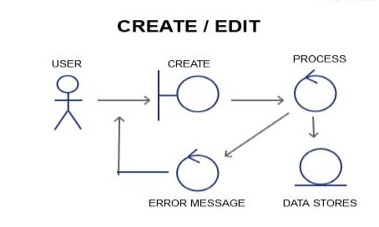

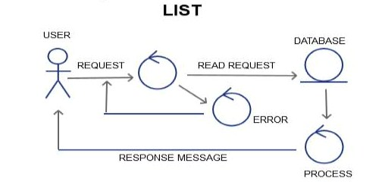

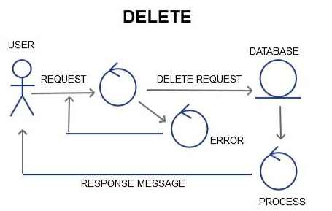

**Class Diagram:**

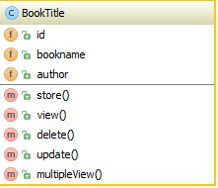

**Sequence Diagram:**

**Create/add /edit**

|  |  |  |
| --- | --- | --- |
|  | Response Message | Validation Failure  Add Request |

|  |
| --- |
|  |

|  |
| --- |
|  |

Storing Data to DB

Sanitization

Unique Validation

Empty Validation

Format Validation

DATABASE

PROCESS

USER/GUI

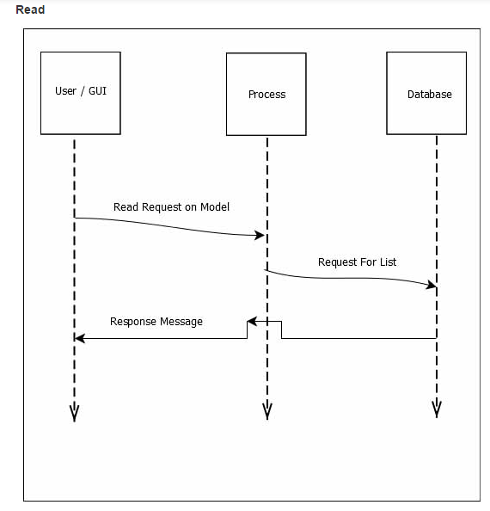

**Delete:**

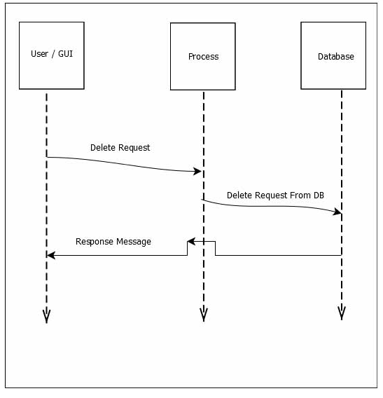

**Schema Diagram:**

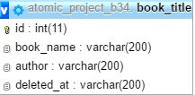

**Mockup:**

**Add:**

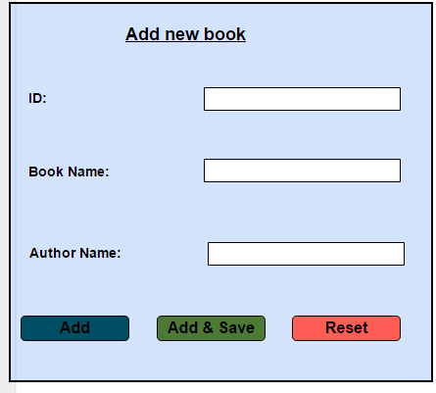

**Edit:**

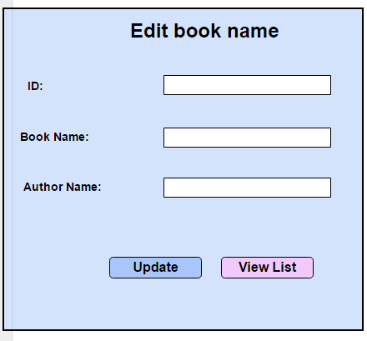

**View:**

